|  |  |  |
| --- | --- | --- |
| **https://lh6.googleusercontent.com/sfRCb4uZ1nLRmzCG01DE2OVaN4BLwYZS77jYyfzxGUpo3yq8RQgdWDX_SOnCeIyRtNEWalWJDNGIb0k2s51BY2Tzg2iPf0nXO2JgOeCO8OJ9endxoQkF2UE3vk45gK31quZJVjfYlxx0UOgM95CIHMkTikY5vPfUq7EjQ1IpTGxp-rMKrqA7EV76Ev9Dl7fsaZ12Fw** | **BAHRIA UNIVERSITY, (Karachi Campus)**  *Department of Software Engineering*  **Assignment 3 - Fall 2022** |  |

COURSE TITLE:      **Calculus and Analytical Geometry** COURSE CODE: **GSC-110**

Class:                       **BSE-I (B)** Shift: **Morning**

Course Instructor:      **Mr. Daniyal ur Rehman** Time Allowed:   **1 Week**

Submission Date:       **11-1-2023** Max. Marks: **5 Marks**

**Question No. 1 [CLO1/3: 5 Marks]**

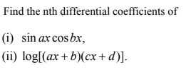



**Question No. 2**

Apply Leibnitz rule of differentiation to find the following





**Question No. 3**

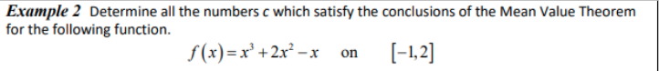



**Question No.** 